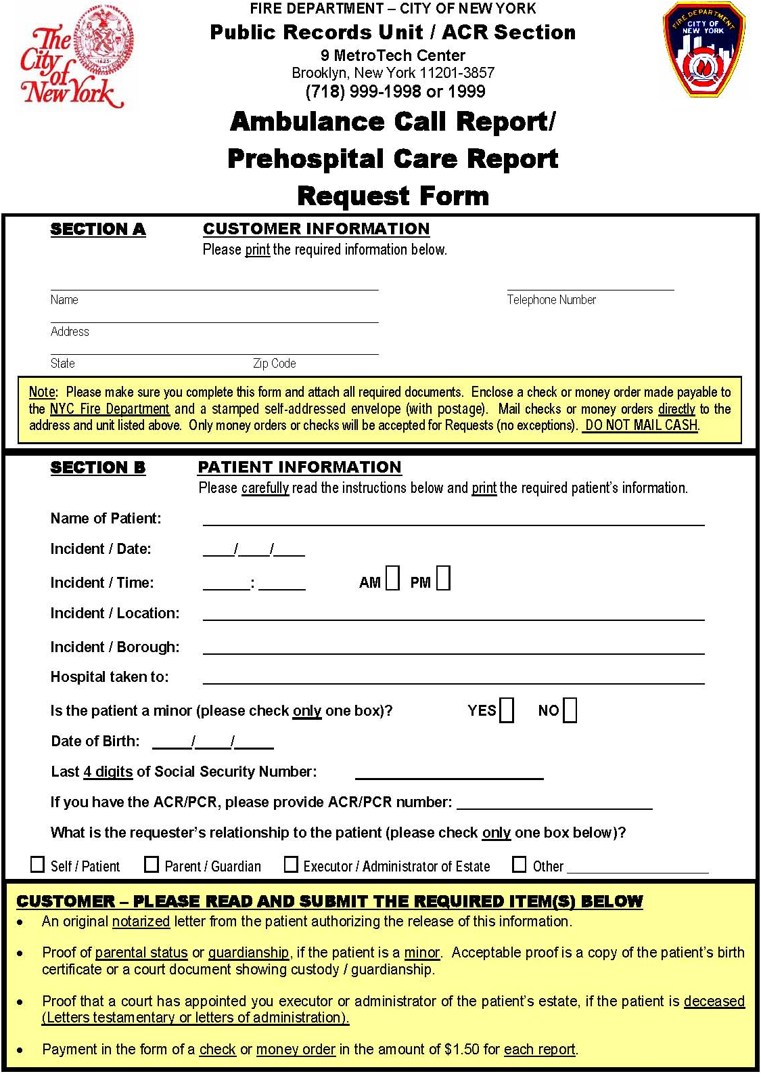
05/15/1967
XXX-XX-5644

Order No.: 01-28625-014
Axiom Requisition Copy Service (877) 886-5090
2869 Jolly Rd
Okemos, MI 48864
Richard Donovan

Defense Attorney
X
Axiom Requisition Copy Service
2869 Jolly Rd, Okemos, Michigan 48864
517.886.5099 – 877.886.5090 toll free – 517.886.4116 facsimile

ADDITIONAL PATIENT INFORMATION REQUIRED

TO: Joel Sklar
OF: Law Offices of Joel B. Sklar
FROM: Leah D. Boroski, Account Executive
OF: Axiom Requisition Copy Service
*****

CUSTODIAN: John M. Telepo as Records Custodian for Triad Metal, Inc.
PATIENT: Richard Donovan
RE: Donovan v. Khan
FILE NO.: 8765.0002
*****

The following information is required so that this location can search for the ambulance transport records being requested:

Name of Actual Ambulance Service that Transported Patient:
______________________________________________________________________
ACR# (Ambulance Care Report) and/or PCR# (Pre-Hospital Care Report):
______________________________________________________________________

Should you have any questions, please feel free to call our office at (877) 886-5090.

Order No. 01-28625-014

